TASK : setup minikube at your local and explore creating namespaces

* Minikube installing (using official website)

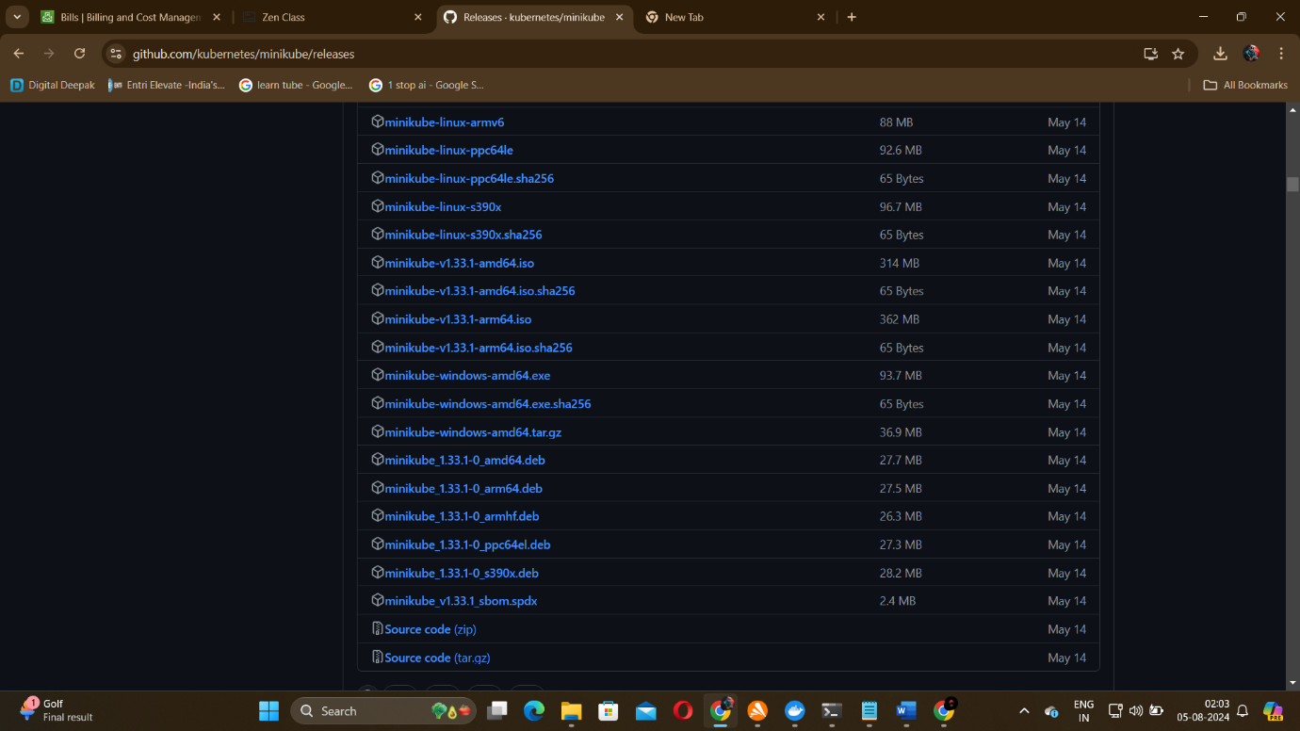

After downloading it copy paste the file to a separate folder in C disk. Rename the downloaded file as “minikube.exe”

To run this minikube we need to enable virtualization using BIOS setup.

I decided to use docker instead which acts as a driver instead of enabling virtualization

So go to docker website and download it for windows

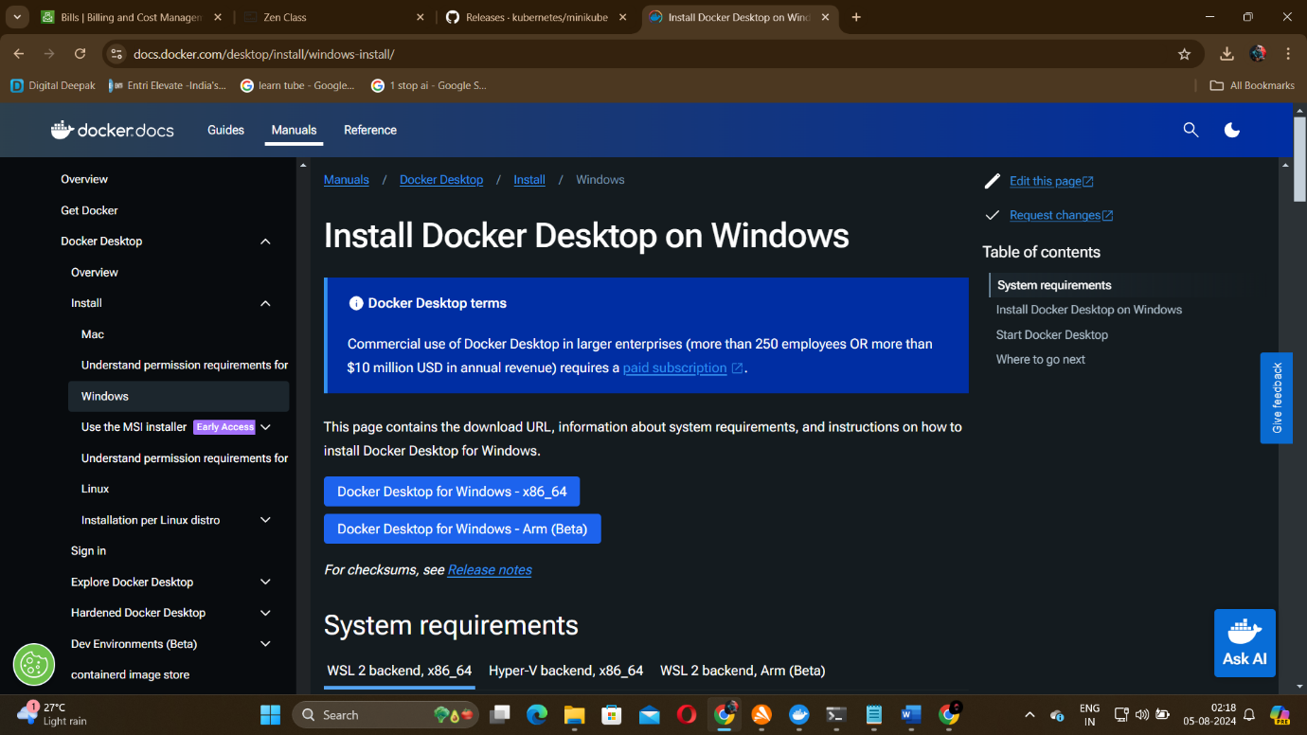

So after downloading this installer follow the execution steps then docker gets downloaded successfully in your desktop

open system variables and edit the path variable and add your folder path [ C:\Program Files\minikube]

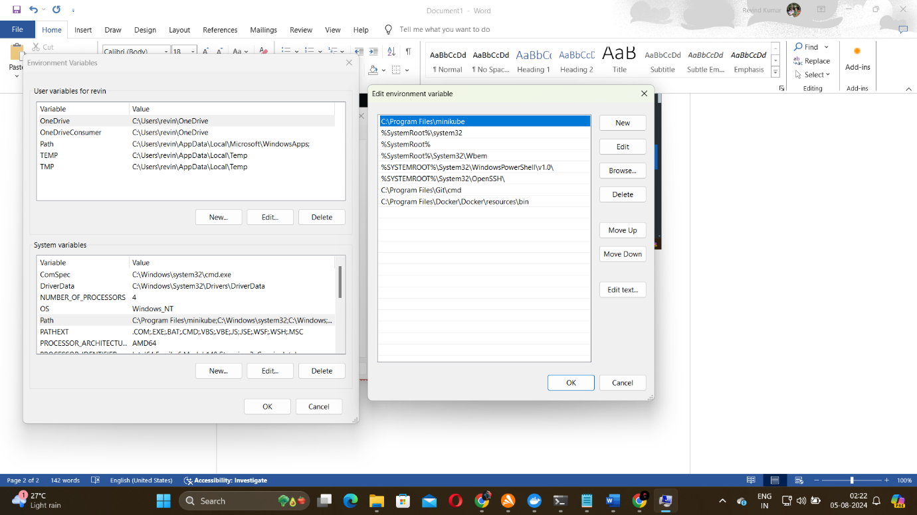 Open powershell

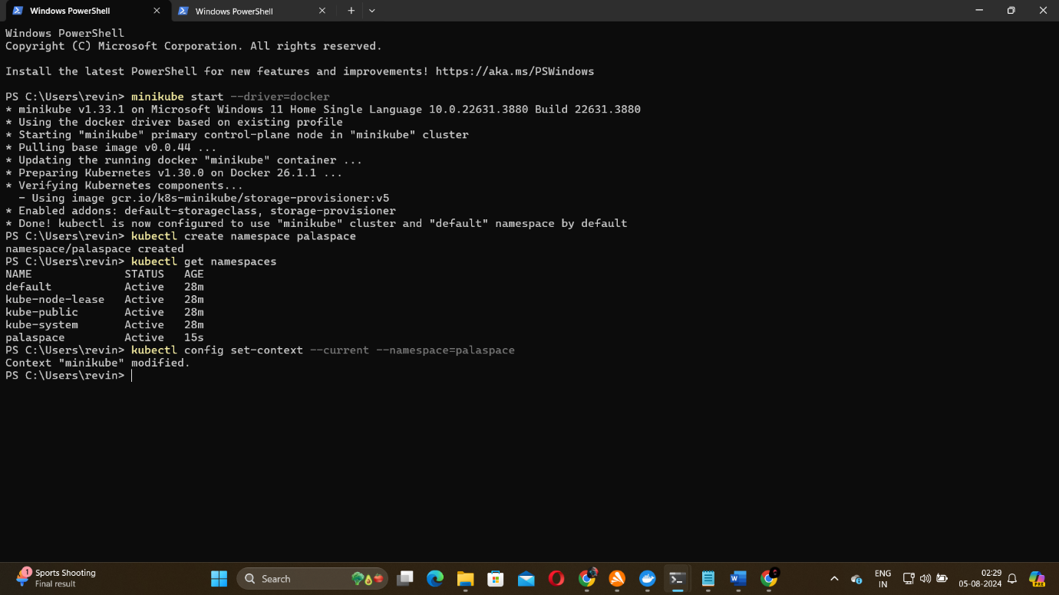

Here I have start minikube using docker and how to create a namespace.